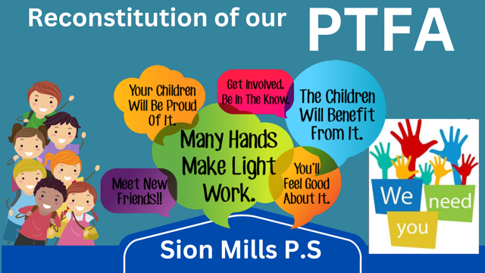

What is the PTFA?

The Parent, Teacher, Friends Association (PTFA) is a group of people who support our school by planning, organising and running events for our children, families and wider community. These events raise much needed funds to provide opportunities, experiences, and resources for our school.

Who can join the PTFA?

Every member of the school community is automatically a member of the PTFA and is welcome to attend any meeting or event. We all lead very busy lives, so you are not expected to commit to every meeting or event, just those that you can manage and at whatever level of involvement you are comfortable with. Ideally we would love parent representation from every class for the effective communication to all parents, pupils and friends of the school.

What are the roles within the PTFA?

As a registered charity at the core of the PTFA is a committee, this is made up of a Chair, Vice-Chair, Secretary, and Treasurer. They ensure that all activities are run as per the legal guidance and expectation of a charity. This committee will be elected at the first meeting in October. There will be no pressure on anyone to assume these roles if they do not wish, we have a committed group of school staff who are willing to guide, support and work together with those that are able to take on these specific roles.

You may wish to:

* Have a position in the committee
* Be actively involved with all meetings and events
* Attend occasional planning meetings and events
* Help out at events on the day

Your involvement, help and support in any capacity will be welcomed at any time throughout the year.

What are our plans for this year?

As we start this academic year, we aim to embrace the positive; with the exciting news of our approved Integrated status we have a lot to look forward to. Through the PTFA we aim to develop relationships and facilitate communication between staff, families, governors and others associated with our school community.

At our first meeting we will agree on:

* our fundraising goals
* an overview of events for the year ahead
* actions to capture the voice of parent/pupil/staff and record their priorities for allocation of PTFA funds
* annual costs of school provisions
* a structured approach to acquiring sponsorship, donations, grants and funds

How will we share our information?

The PTFA will create a Newsletter each term to communicate important information about the team, upcoming events, thanking sponsorships/donations, ways to get involved and our general progress towards reaching our goals.

We will have a parent/ pupil/ friend suggestion box available in our foyer or alternatively you can contact Mrs Kingh on 028816 58249 or by email [lkingh676@sionmills.strabane.ni.sch.uk](mailto:lkingh676@sionmills.strabane.ni.sch.uk)

When is the next meeting?

**TBC- Week beginning 2nd October**

In order to find the most suitable day and time, a Google Form will be sent via Seesaw for parents, staff, and friends to indicate their availability.



*Thank you for your ongoing support*

*Mrs Kingh*